**CHAPTER 1**

**INTRODUCTION**

The Face Recognition Based Attendance Monitoring System is to develop a reliable and efficient automated attendance tracking system using facial recognition technology. This system aims to replace traditional attendance methods, such as manual roll calls or card-based systems, with a more secure and user- friendly approach. By leveraging computer vision and machine learning techniques, the system will accurately recognize and record the attendance of individuals in real-time, thereby reducing the chances of proxy attendance and improving the overall efficiency of attendance management.

**PROBLEM STATEMENT**

Transitioning to Al-based facial recognition can streamline attendance management, Facial recognition reduces manual errors and enhances system accuracy, Modern systems provide better control, visibility, and insights for institutions, this shift improves overall operational efficiency.

## OBJECTIVES

The objective of the Face Recognition Based Attendance Monitoring System are:

* **Development of Face Recognition Model**: Implementing a robust face recognition algorithm using pre-trained models (e.g., Haar Cascade, LBPH, etc.) to accurately identify individuals.
* **Data Management**: Creating a database to store student details, attendance records, and training images.
* **User Interface**: Developing a user-friendly interface for both administrators and users to interact with the system, including functionalities for registration, attendance marking, and report generation.
* **Real-time Attendance Tracking**: Integrating a camera to capture live video streams for real-time face recognition and attendance logging**.**
* **Scalability and Integration**: Designing the system to be easily scalable and integrable with existing school or corporate management systems.

**Chapter 2**

**LITERATURE SURVEY**

**2.1 Title of paper:** Automating attendance management in human resources: A design science approach using computer vision and facial recognition.

**Year: 2024**

**Author/s:** Bao-Thien Nguyen-Tat,Minh-Quoc Bui, Vuong M. Ngo

**Methodology followed:** DSRM is a structured approach for creating and evaluating IT artifacts aimed at solving identified problems. The key phases in this methodology include:

* **Objectives Definition:** Shaping the pursuit of a system that integrates embedded computing with advanced face recognition technologies.
* **Problem Identification and Motivation:** Recognizing the need for an efficient, accurate, and cost- effective face recognition system for attendance management.

**Remarks:**

* **Potential Benefits:** The system offers significant improvements over traditional attendance methods, including reduced errors, increased efficiency, and cost savings.
* **Comprehensive Approach:** The approach involves detection, extraction, labelling, and face recognition, ensuring a seamless and integrated process.

**2.2 Title of paper:** Anti**-**spoofing-enabled Contactless Attendance Monitoring System in the COVID-19 Pandemic.

**Year: 2023**

**Author/s:** Deepti Saraswat, Pronaya Bhattacharaya, Trith Shah, Rushi Satani,Sudeep Tanwar

**Methodology followed:** The authors propose a contactless attendance marking system that utilizes image processing and deep learning techniques to detect and recognize .

* **Mobile Application for Face Scanning**: The authors develop a mobile application using Google Vision API to capture face images when an employee/student comes in front of the camera.
* **Face Recognition:** The authors use the dlib library, a popular open-source face recognition package, to identify individuals. A Python package, face recognition dlib capabilities into API.

**Remarks:**

* The proposed system is contactless, reducing the hassle and burden of traditional attendance marking systems.
* The system is scalable and can be deployed in various settings, including educational institutions and workplaces**.**

**2.3 Title of paper:** Student attendance with face recognition (LBPH or CNN)

**Year: 2022**

**Author/s:** Andre Budiman, Fabiana, Ricky Aryatama Yaputera, Said Achmad, Aditya Kurniawan

**Methodology followed:**

* The study employs a Systematic Literature Review (SLR) methodology to compare various algorithms for face recognition.
* The literature review was conducted using search strategy to gather relevant studies from Google Scholar. The PRISMA framework was utilized to structured and transparent review process.

**Remarks:**

* The paper highlights the rapid advancement of technology and its application in solving student attendance issues at universities. Traditional methods such as manual attendance and RFID-based systems have limitations, including potential cheating and the need for physical cards.

**CHAPTER 3**

**SYSTEM REQUIREMENTS AND SPECIFICATIONS**

**3.1 SCOPE OF THE PROJECT**

The scope of the project is to design and develop a contactless attendance marking system using image processing and deep learning techniques.

* The system aims to provide an efficient, accurate, and secure way to mark attendance in various settings, such as educational institutions and workplaces.
* Designing and implementing a face recognition system using deep learning techniques.
* Creating a database module for storing and retrieving attendance data.
* Developing an anti-spoofing module for liveness detection.
* Integrating the modules to create a seamless attendance marking system.
* Developing a mobile application for face scanning and image capture.
* Testing and evaluating the system's performance and accuracy**.**

**3.2 SOFTWARE REQUIREMENTS**

* **Programming Language:** Python
* **Libraries and Frameworks:** OpenCV, NumPy, Pandas, Tkinter (for GUI)
* **IDE:** Visual Studio Code, PyCharm, or Jupyter Notebook
* **Operating System:** Windows, macOS, or Linux

**3.3 HARDWARE REQUIREMENTS**

* **Processor:** Intel i5 or higher
* **RAM:** 8 GB or higher
* **Storage:** 500 GB HDD or SSD
* **Camera:** HD webcam or equivalent for capturing images

# **CHAPTER 4**

**SYSTEM ANALYSIS**

## Existing Systems

## Manual Attendance:

* + **Process:** Teachers manually call out names and mark attendance on paper.
  + **Challenges:**
    - Time-consuming, especially for large classes.
    - Prone to human errors.
    - Difficult to maintain and retrieve historical records.

**Biometric Systems:**

* + **Process:** Students use fingerprint or iris scanners to mark attendance.
  + **Challenges:**
    - Requires physical contact, which can be unhygienic.
    - Equipment can be expensive and prone to wear and tear..

**Card-Based Systems:**

* + **Process:** Students swipe or scan ID cards to register attendance.
  + **Challenges:**
    - Cards can be lost, forgotten, or swapped among students.
    - Still requires physical interaction, which can be inconvenient.

**Limitations of Existing Systems**

* **Time Consumption:** Manual methods and even some biometric systems can be slow, particularly in large classes or institutions.
* **Accuracy:** Human errors in manual systems can lead to incorrect attendance records.
* **Hygiene:** Biometric systems requiring touch can be unhygienic, especially in situations like the COVID-19 pandemic.
* **Forgery:** Card-based systems can be easily manipulated, leading to inaccurate attendance records.
* **Legal and Regulatory Challenges**: Many jurisdictions have yet to establish clear guidelines and regulations regarding the use of facial recognition technology.
* **User Acceptance**: Not all individuals may be comfortable with their biometric data being used for attendance purposes.
* **Security Risks**: Biometric data, once compromised, cannot be changed like passwords. Therefore, ensuring the security of stored biometric data is critical to prevent identity theft and other malicious activities.
* 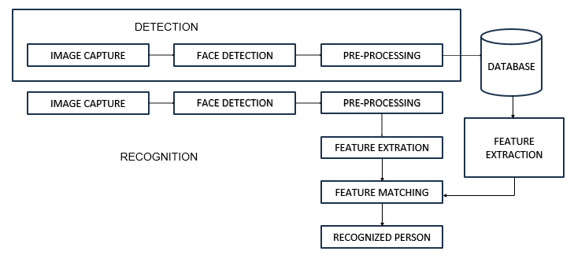**Scalability**: While facial recognition systems can work well in controlled environments (like offices), scaling them to larger or more dynamic settings (such as outdoor events or busy public areas) can be challenging due to the need for more sophisticated algorithms and hardware.

## Fig 4.1 PROPOSED WORKFLOW DIAGRAM

**CHAPTER 5**

**PROPOSED METHODOLOGY**

## 5.1Methodology:

## Data Collection and Preprocessing:

* + **Student Registration:**
    - Capture multiple images of each student.
    - Store images and student details (e.g., name, ID) in a structured database.
* **Image Preprocessing:**
  + - Convert images to grayscale to reduce computational complexity.
    - Normalize images for consistent input to the face recognition model.

**Face Detection:**

* + **Using Haar Cascades:**
    - Utilize OpenCV's Haar Cascade Classifier to detect faces in real-time from a live camera feed.
    - Implement multi-scale detection for accurate face detection.
* **Bounding Box Extraction:**
  + - Draw bounding boxes around detected faces for further processing.

**Face Recognition:**

* + **Model Selection:**
    - Choose a suitable face recognition algorithm (e.g., LBPH, Eigenfaces, Fisherfaces).
* **Training the Model:**
  + - Train the model using preprocessed images from the registration process.
    - Store the trained model for future recognition tasks.
* **Recognition Process:**
  + - Capture real-time images during attendance marking and preprocess them.
    - Use the trained model to recognize faces and match them with the database.
    - Output the recognized student’s ID or name.

**Attendance Marking:**

* + **Timestamp Generation:**
    - Generate a timestamp for each recognized face to record the exact time of attendance.
* **Record Keeping:**
* Update the attendance record in a CSV file or database with student ID, name, date, and timestamp.
* **Daily Report Generation:**
* Generate and securely store a comprehensive attendance report at the end of each day.

By following this proposed methodology, the face recognition-based attendance system aims to provide a streamlined, accurate, and efficient solution for attendance management in educational institutions.

**CHAPTER 6**

**EXPECTED RESULTS**

The system capture images from a camera, recognize faces, and mark the attendance automatically. The below are the snapshots that involves capturing of image and recognizing, adding to database excel sheet.

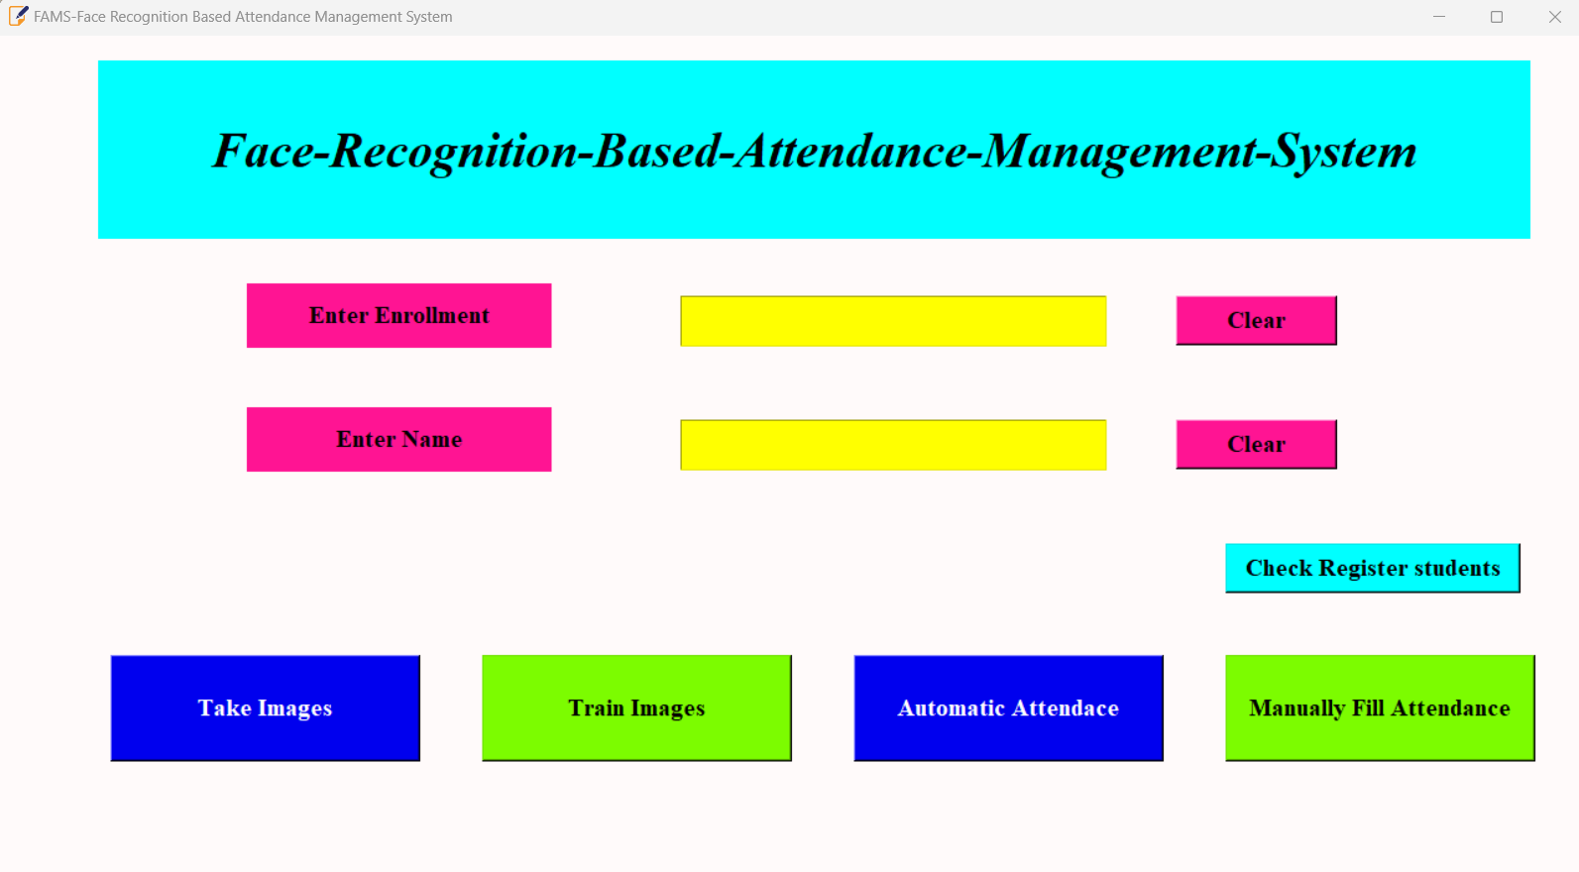**USERS REGISTRATION FORM:**

Fig 6.1 STUDENT REGISTRATION FORM

**PROFILE SAVING:**

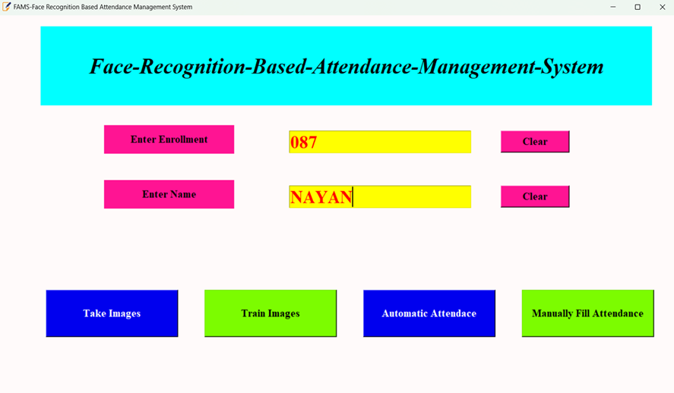

Fig 6.2 STUDENT PROFILE SAVING

## CAPTURING FACE:

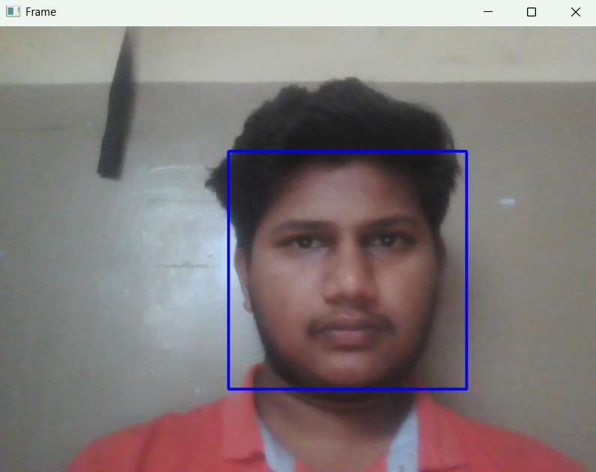

Fig 6.3 STUDENT FACE CAPTURING

**TAKING THE ATTENDENCE:**

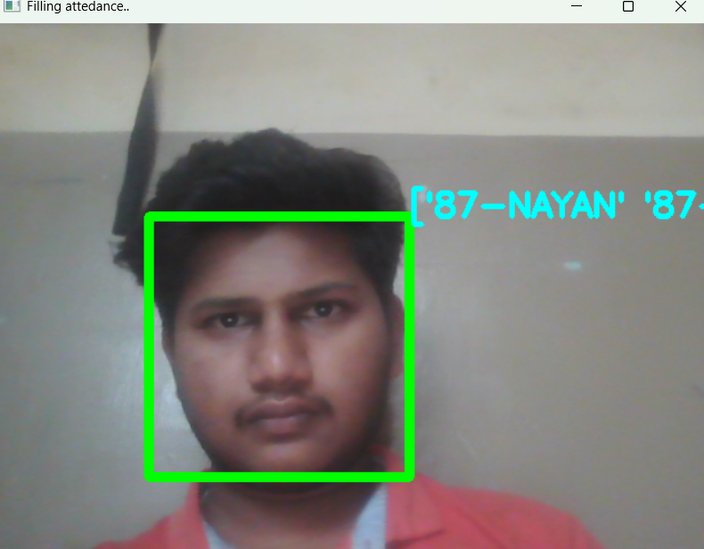

Fig 6.4 TAKING STUDENT ATTENDANCE

**STUDENTS DETAILS:**

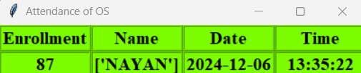

Fig 6.5 DISPLAYING STUDENT ATTENDACE

# **REFERENCES**

[1] W. Zhao, R. Chellappa, P. J. Phillips, and A. Rosenfeld, “Face recognition: A literature survey,” ACM Computing Surveys, 2023, vol. 35, no. 4, pp. 399-458.

[2] T. D. Russ, M. W. Koch, and C. Q. Little, “3D Facial Recognition: A Quantitative Analysis,” 38th Annual 2004 International Carnahan Conference on Security Technology, 2024.

[3] K. Cheng, L. Xiang, T. Hirota and K. Ushijima, “Effective Teaching for Large Classes with Rental PCs by Web System WTS,” in Proc. Data Engineering Workshop 2015 (DEWS2005), 2005, 1D-d3

[4] P. Sinha, B. Balas, Y. Ostrovsky, and R. Russell, “Face Recognition by Humans: Nineteen Results All Computer Vision Researchers Should Know About,” in Proceedings of the IEEE, vol. 94, Issue 11, 2022.

[5] Y.-W. Kao, H.-Z. Gu, and S.-M. Yuan “Personal based authentication by face recognition,” in proc. Fourth International Conference on Networked Computing and Advanced Information Management, pp 81-85, 2023.